Minjuan Luo 20313326 information management

Q1

1

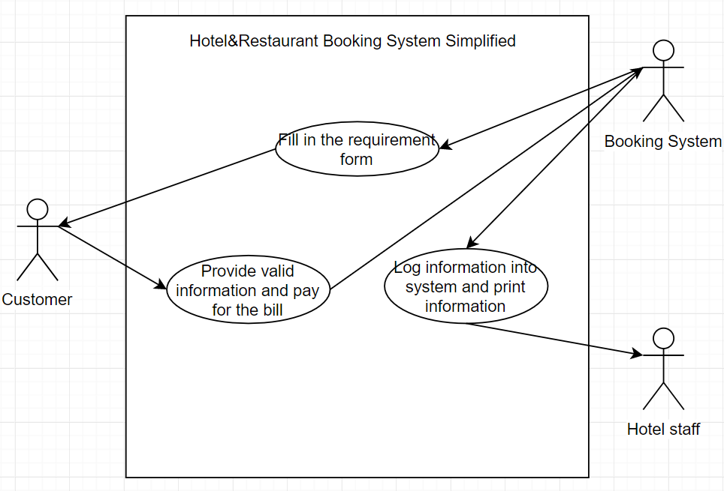

Name: Fill in the requirement form

Participating Actors: Customer, Booking System

Entry Condition:

-Booking System receives successful application.

Exit Condition:

-Booking System informs Customer of successful application

- Booking System informs Customer of unsuccessful application

Normal Scenario:

1.Booking System receives correct syntax application forms

2.Booking System processes application

3.Booking System informs Customer of successful application

4.Booking System receives incorrect syntax application forms

5.Booking System informs Customer of unsuccessful application

Error Scenario:

Booking System processes incorrect Application.

Booking System wrongly destroys or loses Application forms.

-Request multiple resubmissions of application forms from Customer

Name: Provide Valid information and pay for the bill

Participating Actors: Customer, Booking System

Entry Condition:

-Booking System receive valid information.

-Customer provide valid information.

-Customer paid enough fees.

Exit Condition:

-Booking System informs Customer of successful information registration

-Booking System informs Customer of successful payment process

- Booking System informs Customer of unsuccessful information registration

-Booking System informs Customer of unsuccessful payment process

Normal Scenario:

1.Booking System receives valid

2.Booking System register customer personal information

3.Booking System informs Customer of successful information registration

4.Booking System informs Customer to pay fees

5.Customer successfully paid the fees

Error Scenario:

-Booking System processes incorrect information registration

-Booking System wrongly destroys or loses customer information

-Request multiple resubmissions of personal information from Customer

-Customer didn’t provide valid personal information

-Customer don’t have enough money to pay all the fees

Name: Log information into system and print information

Participating Actors: Hotel Staff, Booking System

Entry Condition:

-Booking System receives information successfully

-Booking System log information into the system successfully.

Exit Condition:

- Booking System print out the information to the hotel staff successfully

Normal Scenario:

1.Booking System receives correct information

2.Booking System log information into the system

3.Booking System send information to hotel staff computer

4.Booking System print out customer information to hotel staff

Error Scenario:

-Booking System receives incorrect information

-Booking System can’t log information into the system

-Booking System have an internet failure and cannot send information

-Booking System can’t print out information

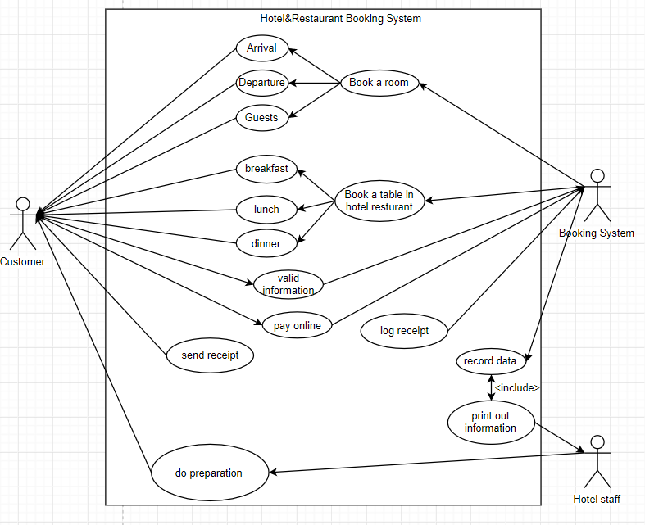

2

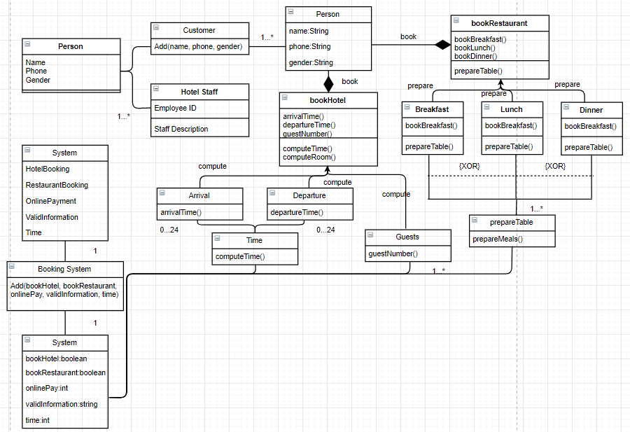

Design description: The customer will first provide valid information to get access into the hotel and restaurant booking form, and then fill in the required information that the system needs. For booking a hotel, the customer needs to fill in their arrival date, departure date and total guests’ number in order to help the hotel staff figure out the number of rooms that the customer needs and do preparation for customer and even for the next customer. For booking a restaurant table, the customer needs to tell the restaurant when will they come so that the staff can prepare correct number of meals and hand them to the customer after they are seated. This information will all log into the booking system and help the staff do plans.

3

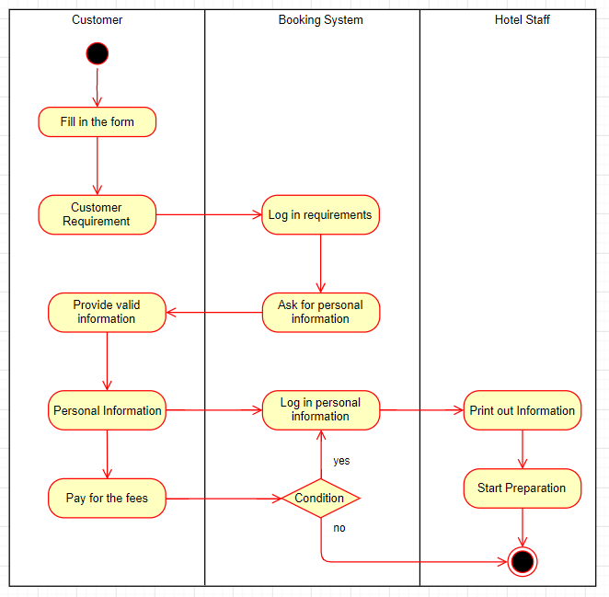

Customer Description: The customer will follow the system instruction provide his requirements, valid personal information and finally pay for the fees at the end of the process

Booking System Description: The system will log in every information that the customer provides in to the system including requirements, personal information and finally ask for paying booking fees. The system will stop sending the information to staff if the payment is stopped or terminated.

Hotel Staff Description: The staff will start preparation after receiving the information provided by the booking system.

4

Individual affected: Can help customer finish booking a hotel or a restaurant without making a phone call to the service desk and easily pay the fees by online payment; Can help the employer of the hotel or restaurant easier to organize the whole service system and get monthly profit data, employee attendance record; For the employee of the hotel, can get the information of the customer in advance so that they can start preparation ASAP.

Behavior Change: The customer’s booking behavior will change from phone booking into online booking because the latter one is more efficient.

The relation between customer and hotel staff will become better because the hotel staff can have enough time to prepare a cleaner room or prepare a more delicious meal which may cause the customer have nicer impression of the hotel or restaurant.

World Views: The views from the world will become more and more confident on technologies because it helps people live a better and more confident live.

5:

Use case diagram: In UML, use-case diagrams model the behavior of a system and help to capture the requirements of the system.

Use-case diagrams describe the high-level functions and scope of a system. These diagrams also identify the interactions between the system and its actors. The use cases and actors in use-case diagrams describe what the system does and how the actors use it, but not how the system operates internally.

Use-case diagrams illustrate and define the context and requirements of either an entire system or the important parts of the system.

Class diagram: In UML, class diagrams are one of six types of structural diagram. Class diagrams are fundamental to the object modeling process and model the static structure of a system. Depending on the complexity of a system, we can use a single class diagram to model an entire system, or we can use several class diagrams to model the components of a system.

Class diagrams are the blueprints of your system or subsystem. we can use class diagrams to model the objects that make up the system, to display the relationships between the objects, and to describe what those objects do and the services that they provide.

Class diagrams are useful in many stages of system design. In the analysis stage, a class diagram can help you to understand the requirements of your problem domain and to identify its components. In an object-oriented software project, the class diagrams that we create during the early stages of the project contain classes that often translate into actual software classes and objects when you write code. Later, we can refine your earlier analysis and conceptual models into class diagrams that show the specific parts of your system, user interfaces, logical implementations, and so on.

Activity Diagram: Activity diagrams area ideal for describing the following processes:

Use cases and the steps described in them,

Business processes or workflows among users and systems,

Software protocol,

Software algorithms

Activity diagrams can be divided into a few areas of responsibility such that these actions can be assigned to particular model elements like classes or components.

Activity diagram is used to show message flow from one activity to another.

Activity is a particular operation of the system. Activity diagrams are not only used for visualizing the dynamic nature of a system, but they are also used to construct the executable system by using forward and reverse engineering techniques. The only missing thing in the activity diagram is the message part.

It does not show any message flow from one activity to another. Activity diagram is sometimes considered as the flowchart. Although the diagrams look like a flowchart, they are not. It shows different flows such as parallel, branched, concurrent, and single.